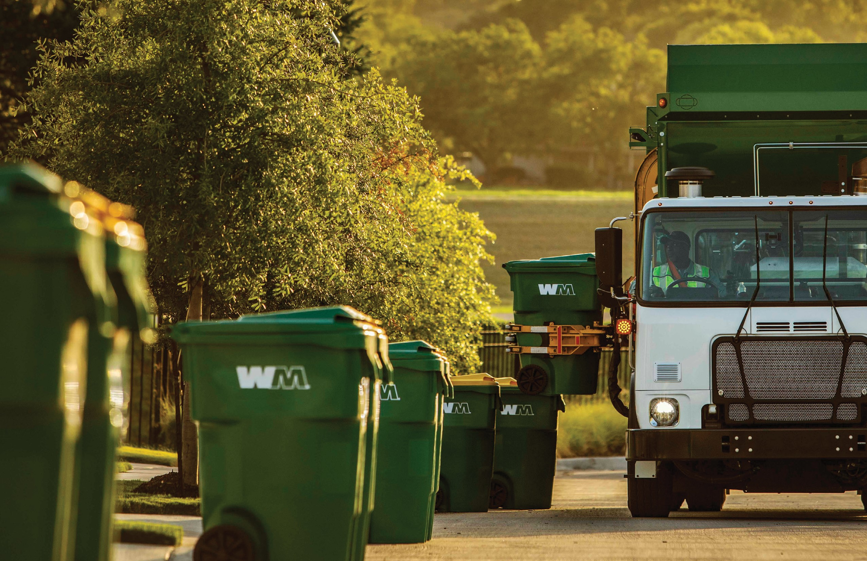SERVICE UPDATE

Trash
Collection with
96-gallon Carts
Beginning on November 1st, trash and yard waste collection will be on Tuesdays.

Important Service Information
Each Heritage Creek resident will be provided with one 96-gallon trash cart at no additional charge, and may request one additional container.
Proper cart placement for automated collection
Remember to place your carts at least 3 feet apart and 3 feet away from any obstacles (trees, cars, mailboxes, etc.) to allow the automatic arm to lift and empty the carts.

7501 Grade Lane
Louisville, KY 40219

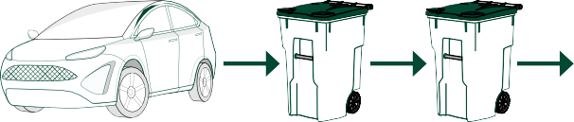
3 ft.
3 ft.
3 ft.

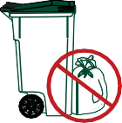
All trash must be bagged and fit inside the WM 96-gallon cart with the lid firmly closed.
No materials, loose trash or bags outside the cart or resident-owned containers will be collected.

Your trash collection day remains the same. Please have your trash cart at the curb no later than 6:00 a.m. on your collection day.
Customer Service
If you have any questions or if you’d like to order an additional cart. Please call WM customer service at (866) 237-7019.

